**Keep Calm and Mask On: Instructions**

**Intro:**

Through several rounds of troubleshooting, this is the mask design that I found maximizes for…

* Versatility (2 sizes, elastics loops adjustable to different sizes & styles by the wearer)
* Comfort & ease of wearing (elastics to make it easier to put on, fitted cut to avoid adjusting during wearing, soft elastics to avoid irritation + strong elastics to avoid slipping on slick hair)
* Fit (wire position, length, & type to make a good seal & prevent glasses fog; nose & chin curves adapted to be comfortable for the testers who were not used to wearing masks)
* Speed (with batching, each mask takes about 30 minutes for someone with hardly any sewing experience beforehand)

I wrote this guide is so others can both benefit from this troubleshooting and continue to iterate on this design. It’s written with the expectation to you own a sewing machine and know the basics of operating it, but don’t necessarily know much else about sewing.

**Equipment:**

rotary cutter & cutting board (or scissors)

fabric pen (or pencil & chalk)

pins & cushion (or small binder clips)

sewing machine

iron & ironing board

**Materials:**

wire (I use 20g floral wire, but 2 twist-ties, pipe cleaners, or wire tie-downs also work)

pattern (cut into cardboard if possible)

fabric (quilter's cotton or flannel)

elastic (I use 3mm soft elastic cord or stretch piping, but fabric hair ties and bias tape also work)

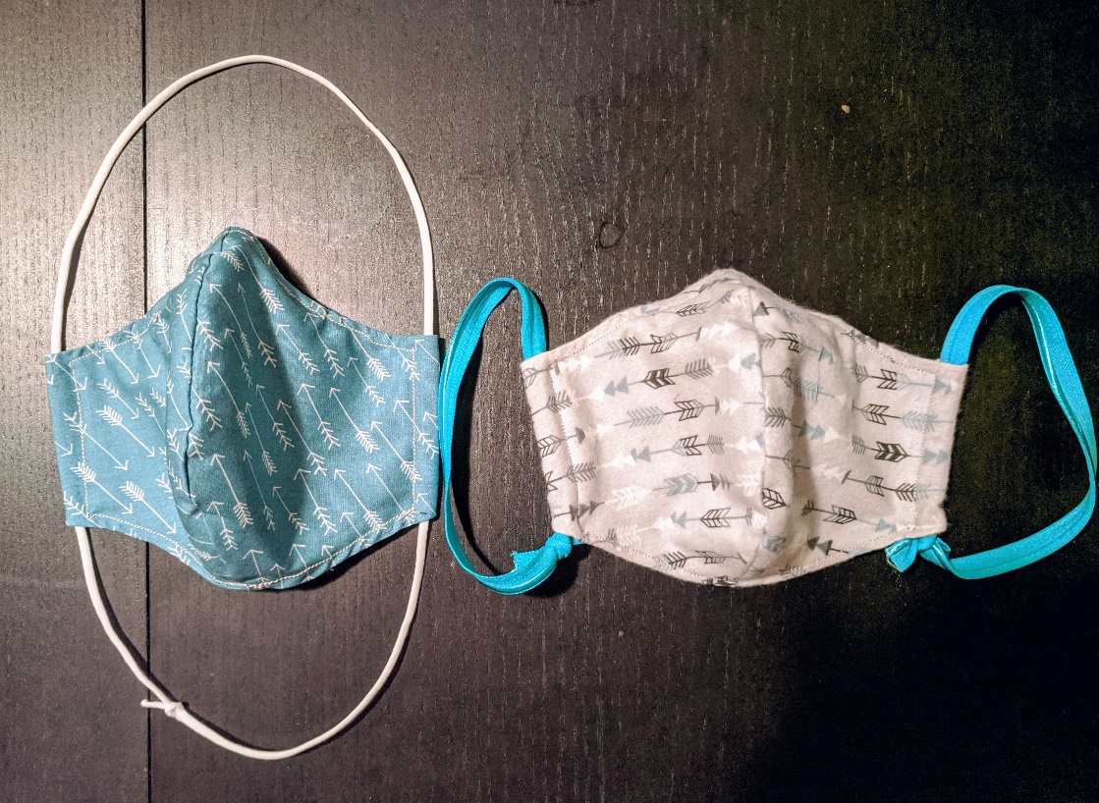

Left: large design, quilting cotton, overhead loops, soft cord elastic

Right: small design, flannel, ear loops, stretch piping

**Instructions:**

1. Unfold the fabric, leaving the last fold together. Trace the pattern and cut. You should end up with 2 matching pieces with the wrong sides facing inwards.

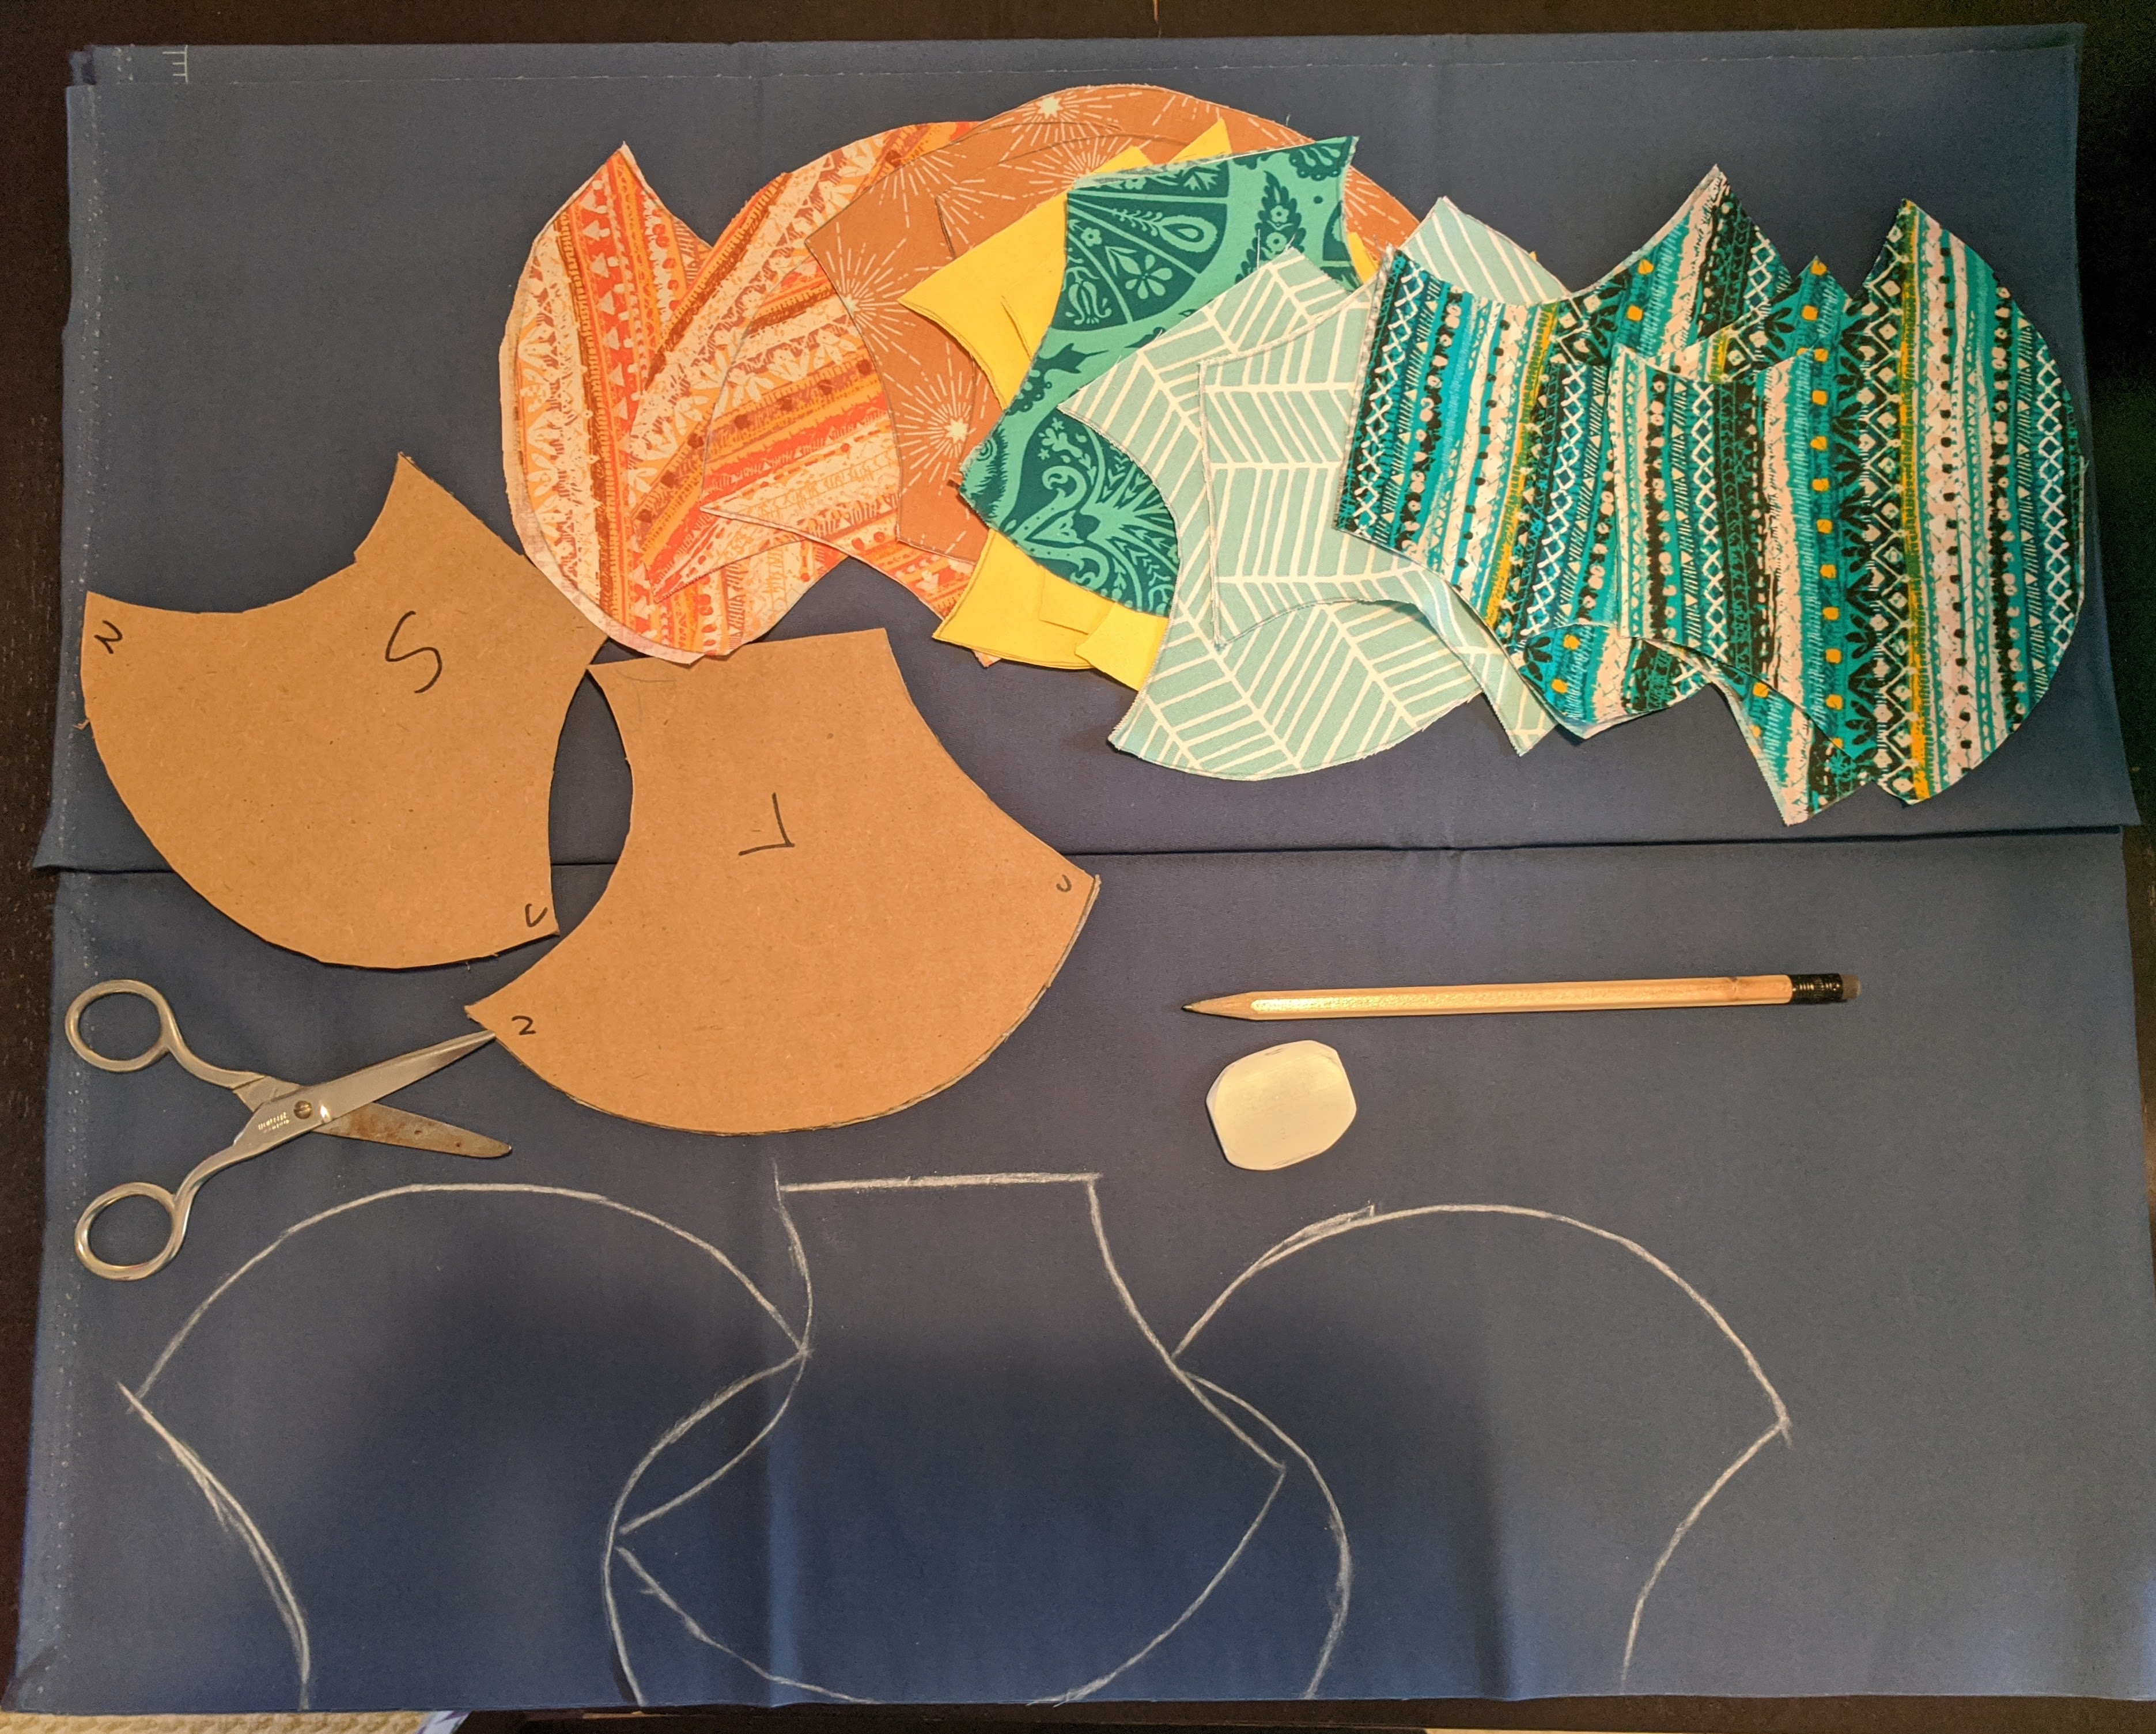

1. With wrong sides facing out, sew the nose to chin seam of each fabric pair. I use a ¼” seam allowance and the smallest stitch setting on my machine for all the seams in this pattern, but that could be adjusted.

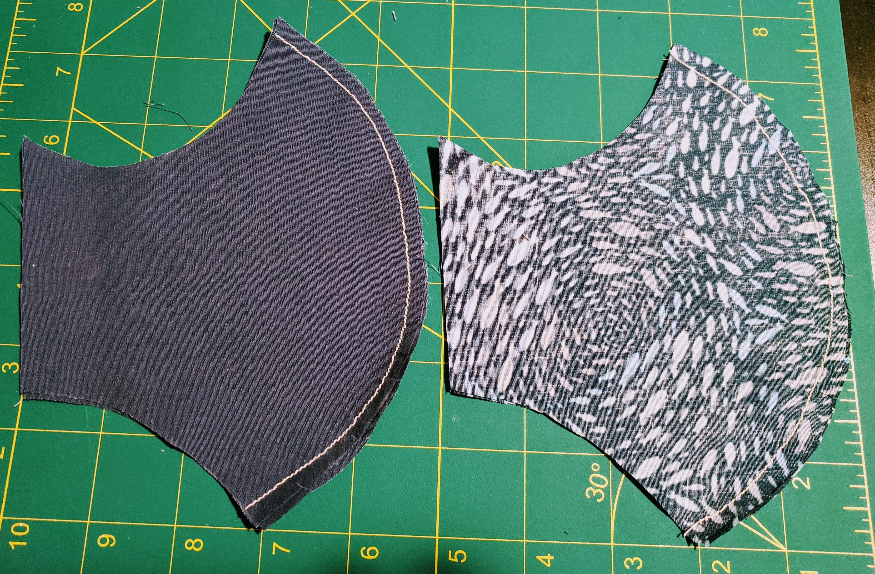

1. Clip the seam fabric at ~1” intervals (don't cut the seam itself) to release tension on the seam when you invert it. Press the seam at the edges (not necessary, but makes the next steps easier).
2. Pin the 2 halves of the mask together at the 4 corners and the top and bottom of the middle seam. Sew them together, leaving 1 side open. Backstitch at the start and end to secure the seam. Flip right side out.
3. Cut a 4” wire and fold the ends in. Bend it slightly to match the curve of the nose part of the mask.
4. Iron seams flat. Place the wire inside along the top of the nose and pin in place. Mark the edges of the wire with the ends of the pins or with a fabric pen. Fold 1/2" in from each side to make the elastics channel. Iron and pin.
5. Starting at a corner, top stitch all around the mask. When you reach the wire, adjust the presser foot so it clears the wire and increase your seam allowance a bit so that you are sewing below the wire. When you reach the elastic channels, sew along the edges. Backstitch and the start and end to secure the seam.
6. Cut elastic: ear loops: 12” for soft cord, 13” for stretch piping; over-head loops: 28” for soft cord, 35” for stretch piping.

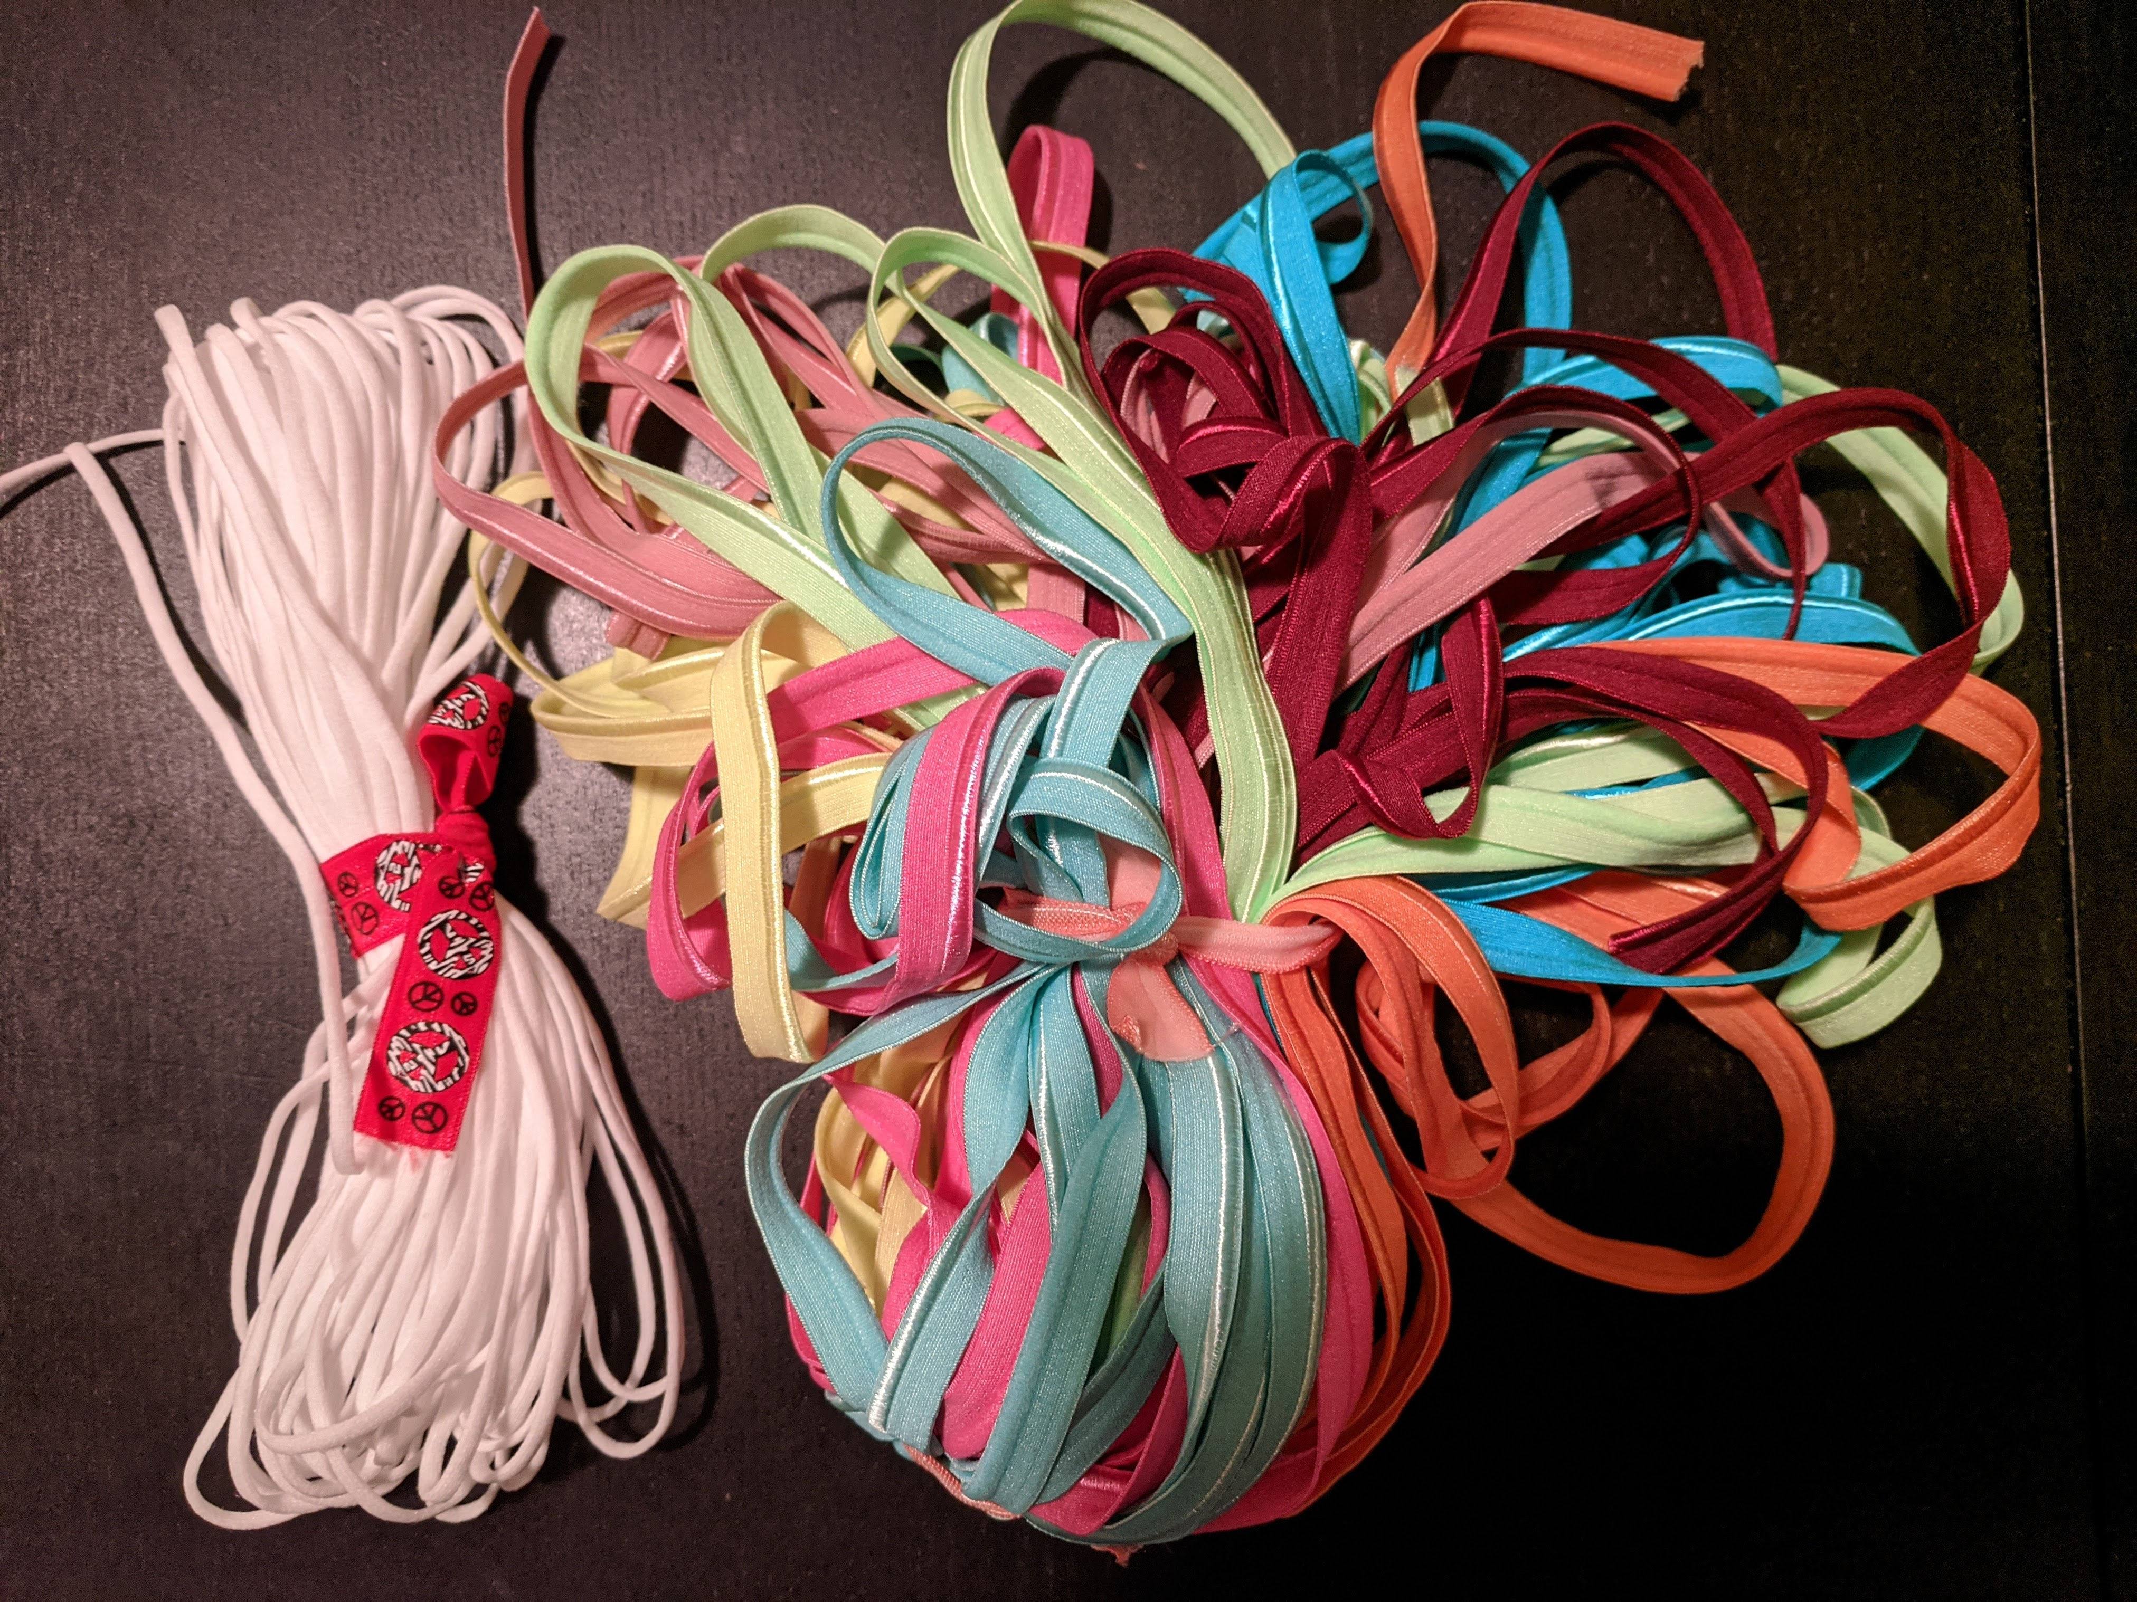

1. Push elastic through the channels with some form of skewer (I use a grilling skewer, but knitting needles, pencils, anything skinny and stiff works). For soft cord ear loops, tie a taut line hitch knot, which makes the cord length adjustable by pulling. For other loop types, let the wearer tie a square knot at their preferred length.

